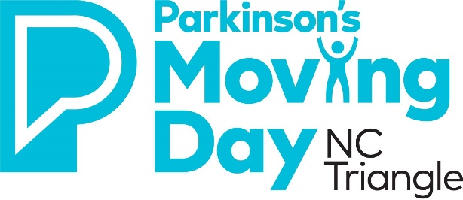
We Move Ceremony - Submit a Nomination Today!
Moving Day NC Triangle
Due October 1, 2021 by 5pm

The We Move Ceremony is a new emotional and engaging presentation at Moving Day. It builds camaraderie and gives participants an opportunity to rally together to beat Parkinson’s. The Ceremony will take place on the Moving Day stage at approximately 11:30am (may move to a later time). During the We Move Ceremony, the ceremony host will recognize four individuals by sharing their story/journey with Parkinson’s.

PLEASE NOTE: The individual you nominate needs to be at Moving Day NC Triangle on November 6, 2021. Further logistical details will be provided soon after the individuals are selected.

We want your help in nominating the four individuals that will be recognized during the We Move Ceremony. Here are the categories (feel free to nominate yourself and you can submit nominations for all categories):
- Person with Parkinson’s
- Someone who cares/cared for someone with Parkinson’s
- Someone who lost a loved one with Parkinson’s
- Someone who helps people with Parkinson’s (physician, therapist, Rock Steady Boxing coach, etc.)

Nomination forms are due by October 1, 2021 at 5pm. Email this the Nomination Form to Diana Parrish at dparrish@parkinson.org. The Moving Day Planning Committee will review all nominations and select one person for each category by November 1, 2021.

Thank you in advance for submitting a nomination!

Sincerely,

Diana Parrish
Development Director
Parkinson’s Foundation Carolinas Chapter

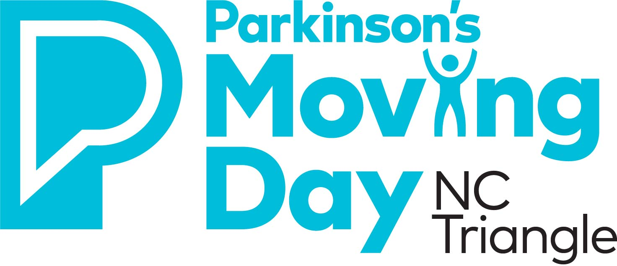
We Move Ceremony Nomination Form
Moving Day NC Triangle 2021
Due October 1, 2021 by 5pm
Your Contact Information:

Name: ______________________________________________________________________________
Email: _____________________________________ Phone: __________________________________

Contact Information for Person Being Nominated:

Name:______________________________________________________________________________
Email: ___________________________________ Phone: ____________________________________

Please check off the category you are nominating this individual for:

- Person with Parkinson’s
- Someone who cares/cared for someone with Parkinson’s (Caregiver)
- Someone who lost a loved one with Parkinson’s
- Someone who helps people with Parkinson’s (physician, therapist, Rock Steady Boxing coach, etc.)

- Tell us about the nominee’s Parkinson’s story/journey?

- How has this individual inspired you?

- What connection does this person have to the Parkinson’s Foundation?

