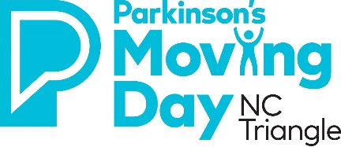
Moving Day NC Triangle 2021 T-Shirt Contest
Entry Form
Team Name: ____________________________________________
Team Contact Name: _____________________________________
Team Contact Email: ______________________________________
Team Contact Phone: ______________________________________
Entry Guidelines
- All registered teams can enter the t-shirt contest.
- Winning team will get $1,000 donated by Right at Home that will count towards their team fundraising goal.
- At Moving Day all registered participants will get a ‘voting ticket’ at the Registration tent. They will place their ticket in the appropriate ‘voting box’ for their favorite t-shirt. Prior to the ‘walk’ Right at Home will get on stage and announce the top 3 based on votes received. Top 3 will be announced and asked to come to the stage around 11:30am.
- Winner will be determined by participants at Moving Day whereby participants will hear the story behind the t-shirt design from the top 3. The winner will be determined by the applause-o-meter during the event.
- Winning team will be presented a check by Right at Home for $1,000 on stage.
- Submitting T-Shirt for Contest – Deadline is November 3rd at 5 p.m.
  - Drop off at Right at Home in Raleigh or Durham (see addresses below)
  - Mail to Right at Home in Raleigh, Attn: Tim Wach
  - Email Karson at kterry@parkinson.org if the above two options are not viable.
- Complete and sign this entry form and return to Karson Terry via email (kterry@parkinson.org) by 5 p.m. on November 3rd (t-shirts must be delivered to above locations by this time as well):
Right at Home Right at Home
Attn: Tim Wach Attn: Tim Wach
2500 Blue Ridge Rd., Suite 301 4905 Pine Cone Drive, Suite 2
Raleigh, NC 27607 Durham, NC 27707
919-783-5633 919-237-2333

